Based on your project structure and the fixes we've already made, here's the complete step-by-step guide to run the Multi-Agent AI Business Assistant locally with all 3 services.

Multi-Agent AI Business Assistant
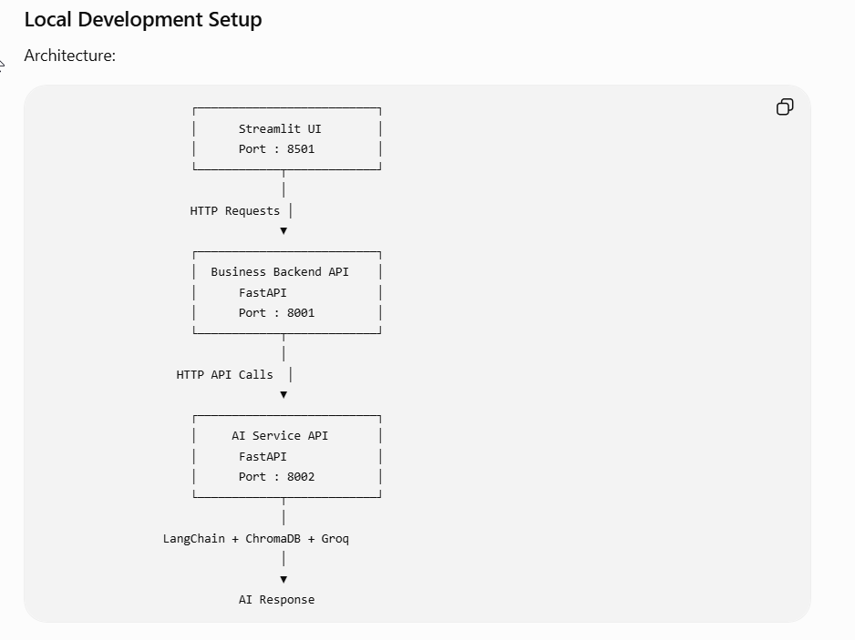
Local Development Setup
Architecture:
┌──────────────────────────┐
│ Streamlit UI │
│ Port : 8501 │
└────────────┬─────────────┘
│
HTTP Requests │
▼
┌──────────────────────────┐
│ Business Backend API │
│ FastAPI │
│ Port : 8001 │
└────────────┬─────────────┘
│
HTTP API Calls │
▼
┌──────────────────────────┐
│ AI Service API │
│ FastAPI │
│ Port : 8002 │
└────────────┬─────────────┘
│
LangChain + ChromaDB + Groq
│
▼
AI Response

Project Folder
Multi-Agent-AI-Business-Assistant
│
├── frontend
├── backend-business
├── ai_service

Step 1
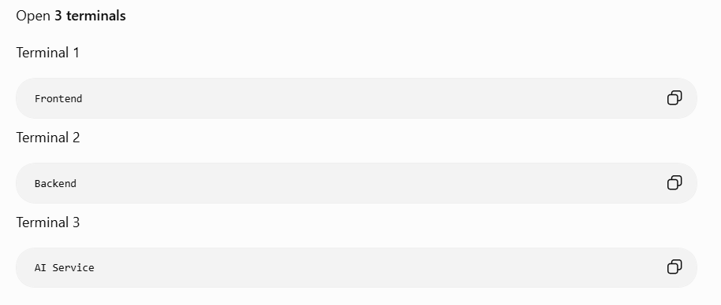
Open 3 terminals
Terminal 1
Frontend
Terminal 2
Backend
Terminal 3
AI Service

Step 2
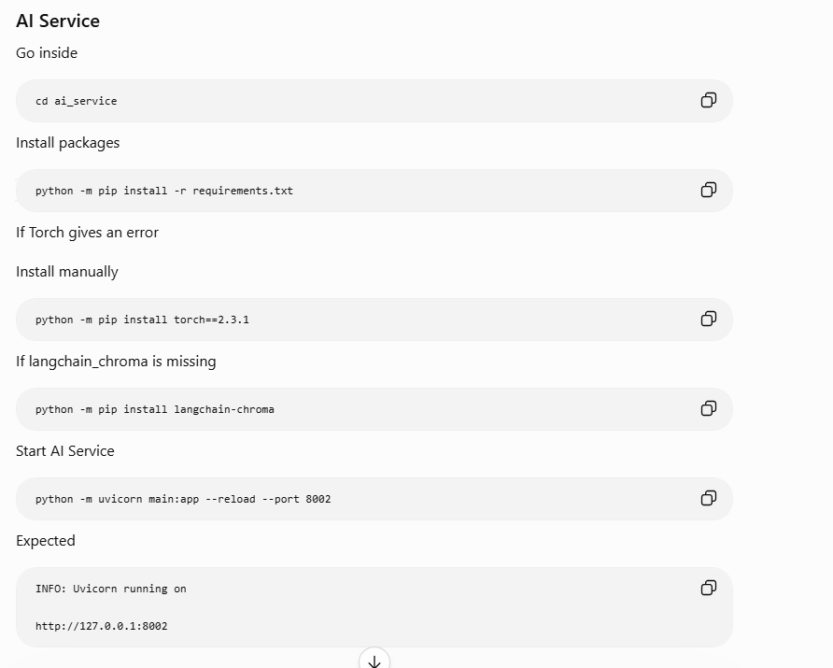
AI Service
Go inside
cd ai_service
Install packages
python -m pip install -r requirements.txt
If Torch gives an error
Install manually
python -m pip install torch==2.3.1
If langchain_chroma is missing
python -m pip install langchain-chroma
Start AI Service
python -m uvicorn main:app --reload --port 8002
Expected
INFO: Uvicorn running on

http://127.0.0.1:8002

Step 3
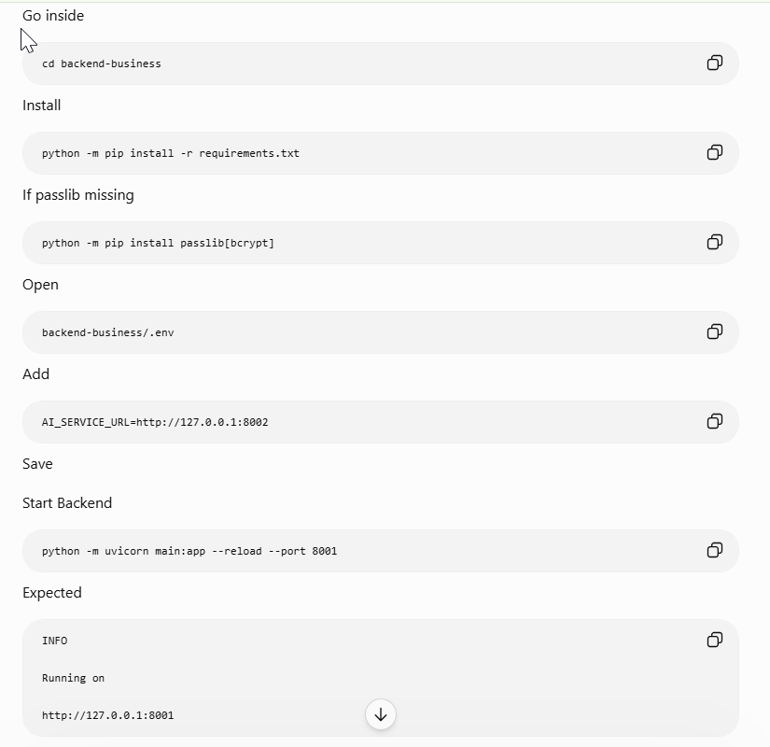
Backend Business
Go inside
cd backend-business
Install
python -m pip install -r requirements.txt
If passlib missing
python -m pip install passlib[bcrypt]
Open
backend-business/.env
Add
AI_SERVICE_URL=http://127.0.0.1:8002
Save
Start Backend
python -m uvicorn main:app --reload --port 8001
Expected
INFO

Running on

http://127.0.0.1:8001

Step 4
Frontend
Go inside
cd frontend
Install
python -m pip install -r requirements.txt
Start
streamlit run main.py
Expected
Local URL

http://localhost:8501

Running Services
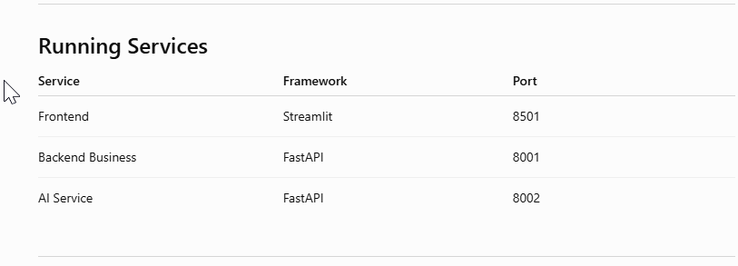
Service | Framework |  | Port
Frontend | Streamlit |  | 8501
Backend Business | FastAPI |  | 8001
AI Service | FastAPI |  | 8002

API Communication
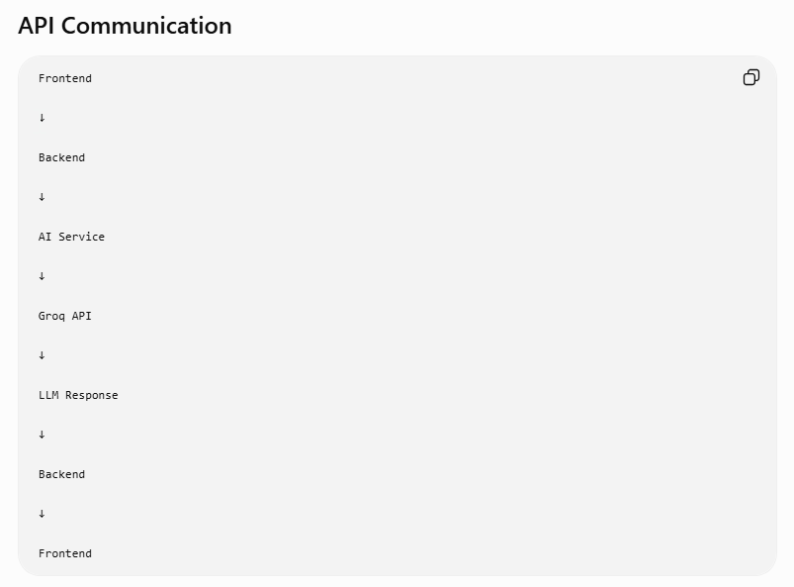
Frontend

↓

Backend

↓

AI Service

↓

Groq API

↓

LLM Response

↓

Backend

↓

Frontend

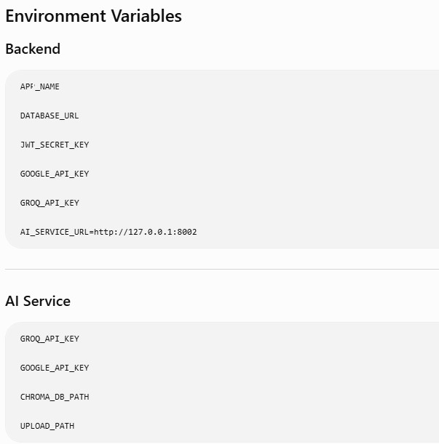
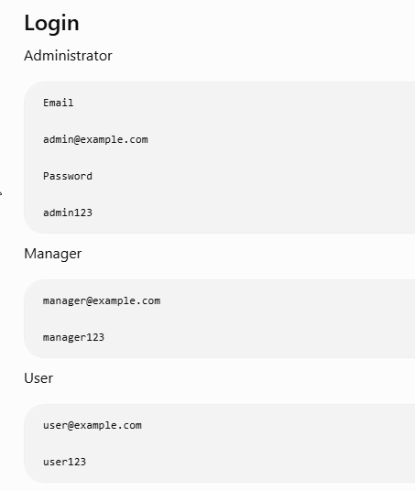
Environment Variables
Backend
APP_NAME

DATABASE_URL

JWT_SECRET_KEY

GOOGLE_API_KEY

GROQ_API_KEY

AI_SERVICE_URL=http://127.0.0.1:8002

AI Service
GROQ_API_KEY

GOOGLE_API_KEY

CHROMA_DB_PATH

UPLOAD_PATH

Login
Administrator
Email

admin@example.com

Password

admin123
Manager
manager@example.com

manager123
User
user@example.com

user123

API Endpoints
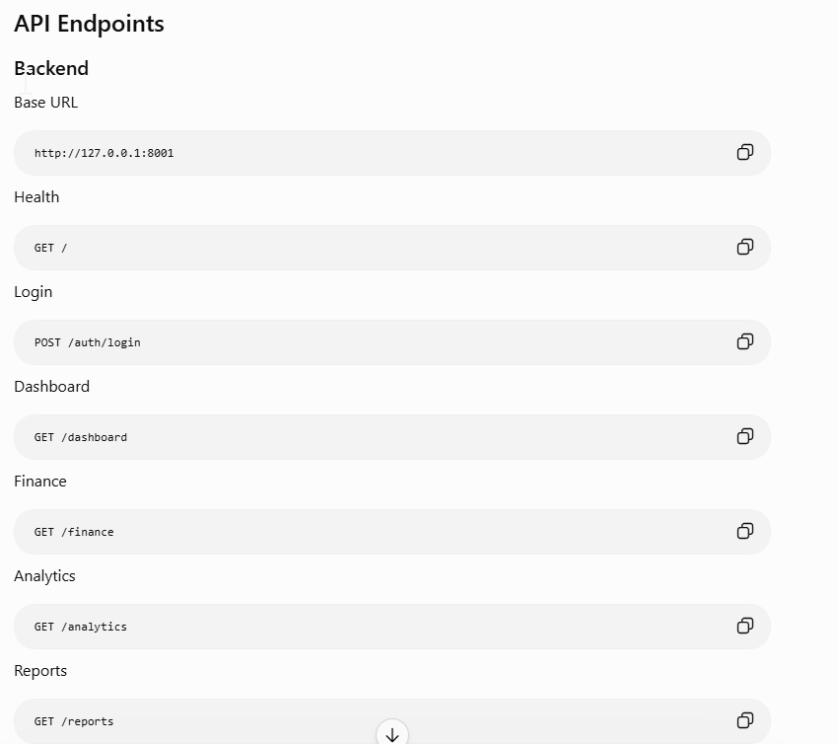
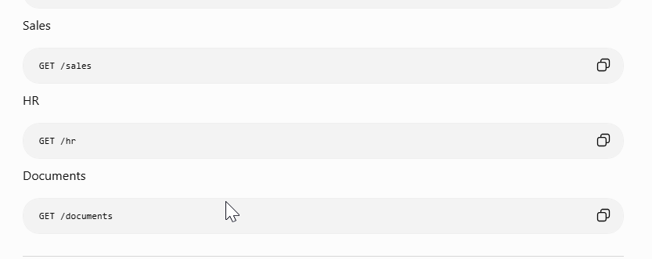
Backend
Base URL
http://127.0.0.1:8001
Health
GET /
Login
POST /auth/login
Dashboard
GET /dashboard
Finance
GET /finance
Analytics
GET /analytics
Reports
GET /reports
Sales
GET /sales
HR
GET /hr
Documents
GET /documents

AI Service
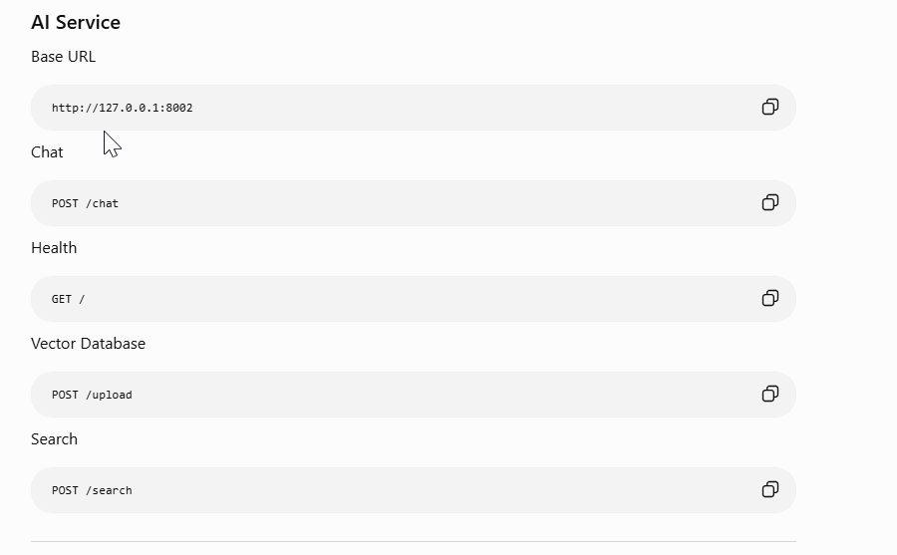
Base URL
http://127.0.0.1:8002
Chat
POST /chat
Health
GET /
Vector Database
POST /upload
Search
POST /search

Request Flow
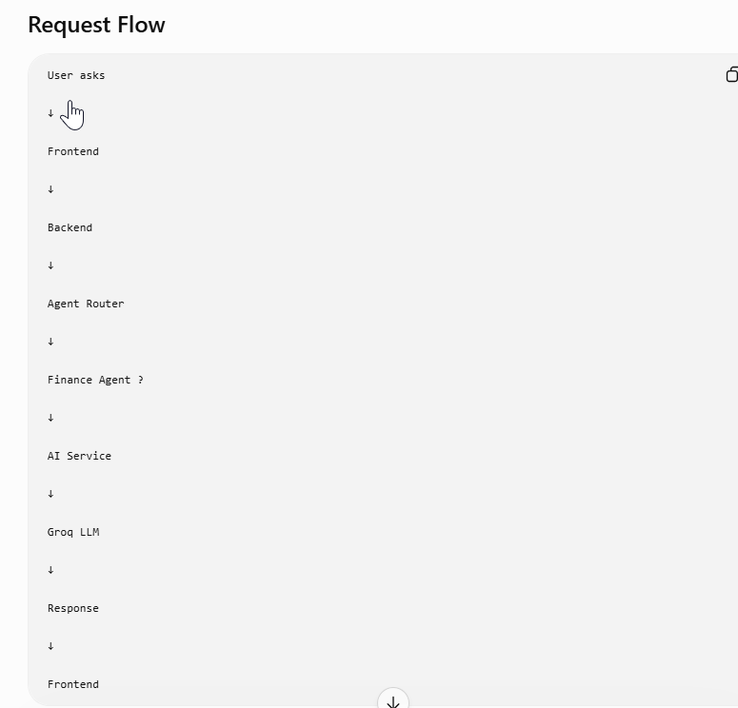
User asks

↓

Frontend

↓

Backend

↓

Agent Router

↓

Finance Agent ?

↓

AI Service

↓

Groq LLM

↓

Response

↓

Frontend

Example Questions
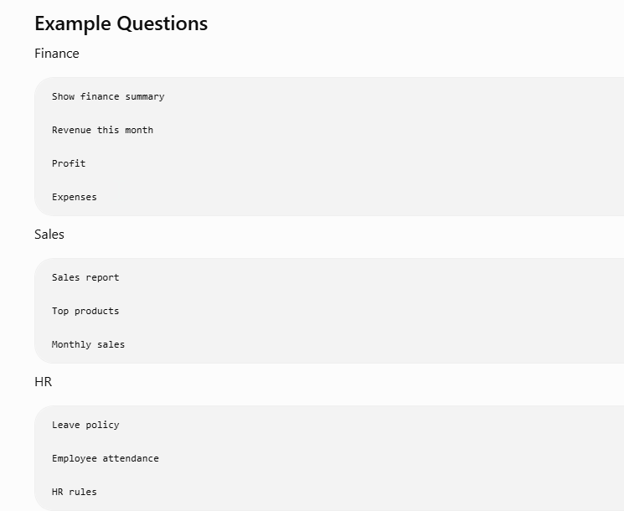
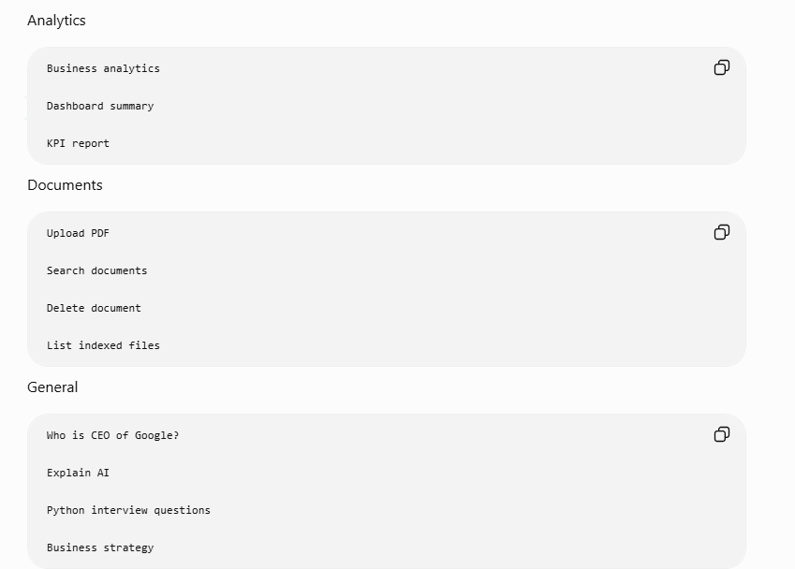
Finance
Show finance summary

Revenue this month

Profit

Expenses
Sales
Sales report

Top products

Monthly sales
HR
Leave policy

Employee attendance

HR rules
Analytics
Business analytics

Dashboard summary

KPI report
Documents
Upload PDF

Search documents

Delete document

List indexed files
General
Who is CEO of Google?

Explain AI

Python interview questions

Business strategy

Health Check
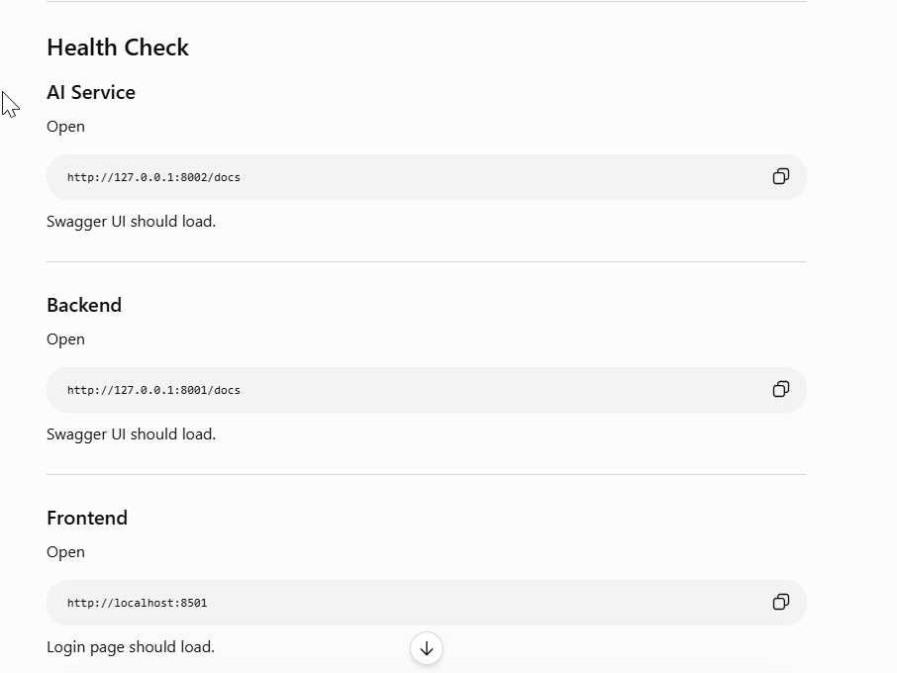
AI Service
Open
http://127.0.0.1:8002/docs
Swagger UI should load.

Backend
Open
http://127.0.0.1:8001/docs
Swagger UI should load.

Frontend
Open
http://localhost:8501
Login page should load.

Startup Order (Important)
Always start the services in this order:
- AI Service (Port 8002) – Provides LLM and RAG functionality.
- Backend Business (Port 8001) – Depends on the AI Service.
- Frontend Streamlit (Port 8501) – Connects to the Backend API.
Following this sequence ensures that each service can successfully connect to the one it depends on.
